**Design Idea 1:**

* **Chatbot :** A conversational AI-powered chatbot designed to provide immediate assistance and support to users, handling frequently asked questions, offering guidance, and facilitating smooth interactions through text, images or videos

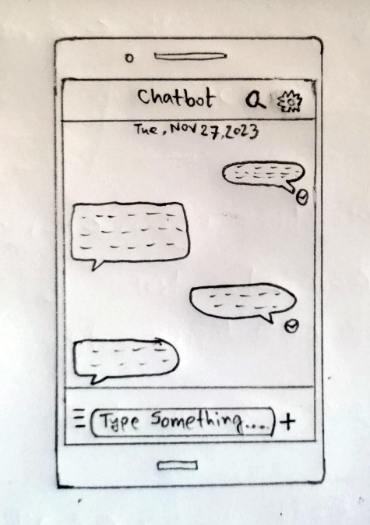

* **Insights from Affinity Diagrams :** Through affinity diagrams, it was evident that users often require quick and accessible information. Many queries were repetitive and could be addressed through an automated system by saving time and resources. All these things have motivated us to develop this design idea.
* **Strengths and Weaknesses :**
* **Strengths :**
* Provides instant responses
* Reduces human intervention for common queries
* Enhances user experience through 24/7 availability
* **Weaknesses :**
* Limited ability to handle complex queries
* Initial setup and training may require significant effort
* User dissatisfaction due to misunderstandings or lack of context
* The chatbot solves the issue of delayed responses to common queries by instantly addressing them. It streamlines support services and reduces the workload on human agents, enabling them to focus on more complex tasks.
* **Supporting User Needs and Adoption :** The design offers immediate assistance, simplifies interactions, and is accessible round the clock. Users can easily adapt due to its user-friendly interface and convenience. They would interact with the system by asking questions, seeking guidance, or requesting specific information.

**Design Idea 2:**

* **AI-based Task Manager :** A comprehensive task management system utilizing AI to prioritize tasks, set reminders, and optimize productivity by learning user behavior and preferences

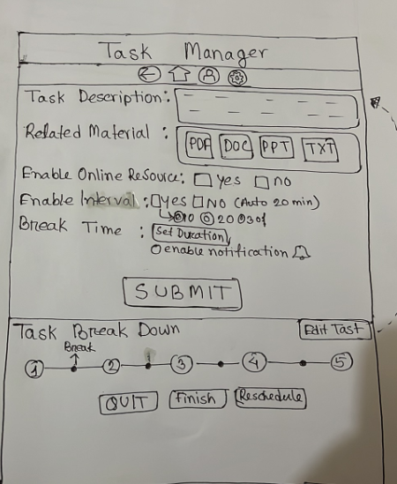

* **Insights from Affinity Diagrams :** Discovered user struggles with task prioritization, time management, and a desire for a personalized approach to task scheduling.
* **Strengths and Weaknesses :**
* **Strengths :**
* Intelligent task prioritization based on deadlines and user preferences
* Automation of routine tasks for enhanced productivity
* Customizable features to adapt to different work styles
* **Weaknesses :**
* Initial setup complexity and learning curve for users
* Dependency on accurate data input for effective task management
* Potential limitations in handling highly complex or creative tasks
* The AI task manager solves the problem of task overload and inefficiency by organizing and prioritizing tasks based on user habits and preferences.
* **Supporting User Needs and Adoption :** Users adopt the system by integrating it into their workflow, appreciating its ability to streamline tasks, personalize reminders, and enhance productivity.

**Design Idea 3:**

* **Research Paper Summarizing AI Tool :** An AI tool specifically designed to read and summarize research papers, extracting key points and generating concise summaries for easier comprehension

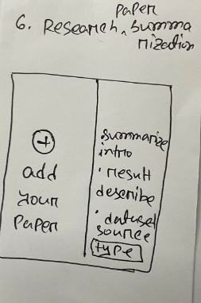

* **Insights from Affinity Diagrams :** Noticed researchers spending significant time reading and summarizing multiple papers, highlighting the potential for a tool to expedite this process.
* **Strengths and Weaknesses :**
* **Strengths :**
* Assists in data organization and analysis
* Offers relevant resource suggestions based on research topics
* Enhances efficiency in synthesizing information
* **Weaknesses :**
* Might struggle with niche or highly specialized topics
* Initial setup and customization might be time-consuming
* Over-reliance leading to lack of critical thinking in research
* This research paper summarizing AI tool resolves the time-consuming nature of reading and summarizing multiple research papers, enabling researchers to focus on analysis and insights.
* **Supporting User Needs and Adoption :** Users find value in quicker access to key information from papers, facilitating faster comprehension and aiding in their research processes. Adoption requires trust in the accuracy of generated summaries and integration into their research workflow.
* **Shortlisted Design Ideas for Prototyping :**
* The ideas have been selected based on the magnitude of the problem identified and the feasibility of addressing it with AI technology.
* These ideas were chosen because they align with user needs, have the potential for substantial impact, and could be feasibly implemented using available AI capabilities and resources.
* **Scan/photo(s) of low-fidelity prototype :**

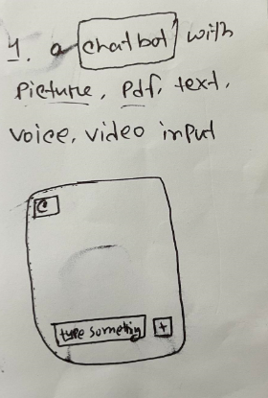 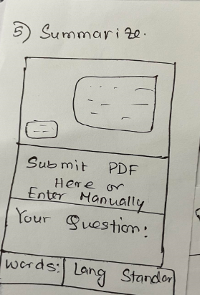 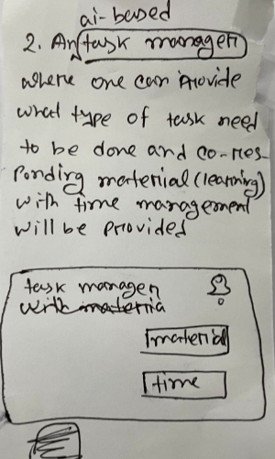

  

* **User Study Protocol :**
* **Short Introduction :** Hello, I am a researcher conducting a study to understand the challenges faced by students, faculty, and researchers in using AI tools within academia. The purpose of this study is to identify hurdles, improve understanding, and enhance the utilization of AI tools in educational settings.
* **Project Description :** This project aims to address the challenges encountered by individuals using AI tools in academia. The goal is to explore the difficulties related to understanding AI functionality, biases in models, contextual awareness, technical issues, digital literacy skills, and tool selection uncertainties. The context involves the increasing integration of AI in education and the necessity for individuals to effectively utilize these tools.
* **Opportunity for Participant Questions :** Before we begin, I welcome any questions you might have about the study, its goals, or the tasks we'll be undertaking.
* **Introduction to Think Out Loud :** During this session, I encourage you to think out loud. This means verbalizing your thoughts, reactions, and decision-making process as you navigate through the tasks. Your insights will help us understand your perspective better.
* **Introduction to Scenarios and Tasks :**
* **Task 1: Understanding AI Basics**

**Scenario:** Imagine you're explaining AI to a colleague unfamiliar with the concept. What key points would you cover to ensure they understand the fundamental aspects of AI?

* **Task 2: Identifying Biases in AI Models**

**Scenario :** You encounter an AI tool that's providing different results based on gender. How would you identify and address biases in this situation?

* **Task 3: Contextual Awareness and Utilization**

**Scenario :** You need to use an AI tool for a research project but find that it doesn't consider cultural context. How would you adapt or enhance the tool's contextual awareness for your project?

* **Task 4: Digital Literacy and Tool Selection**

**Scenario :** You're tasked with selecting an AI tool for a specific academic project. How would you go about assessing its suitability and ensuring it meets your requirements?

* **Thank You and Opportunities for Questions :** Thank you for your participation. If you have any further questions or thoughts you'd like to share regarding the tasks or the study itself, please feel free to ask.
* **User Testing Findings :**
* Users found the explanation unclear in certain areas. They suggested incorporating more visual aids to simplify complex concepts.
* Users struggled to identify biases effectively. They recommended having clear prompts or examples to guide them through recognizing and addressing biases.
* Users encountered difficulty in adapting AI tools for different contexts. They proposed having contextualization features integrated into the tool itself.
* Users expressed confusion in evaluating the suitability of AI tools. They suggested a checklist or decision-making guide to assist in the selection process.
* **Updated Lo-fi Prototype :**
* **Task 1 :**
  + Added visual diagrams explaining AI concepts
  + Included step-by-step explanations with accompanying visuals for clarity
* **Task 2 :**
  + Included clearer prompts and examples to assist users in recognizing biases
  + Added a guided process to address identified biases within the tool.
* **Task 3 :**
  + Integrated contextualization features within the AI tool interface
  + Incorporated options to adapt the tool for different cultural contexts
* **Task 4 :**

* + Created a decision-making guide/checklist to aid users in evaluating AI tools
  + Included additional information on how to assess the suitability of tools for specific tasks

